**COMSATS University Islamabad, Lahore Campus**

**Subject :** Object Oriented Programming

**Assignment :**  4

**Submitted To :** Sir Shahid Bhatti

**Muhammad Ahmad Iqbal(SP24-BSE-065)**

**Muhammad Waqar(SP24-BSE-091)**

**Submitted By :**

**Section :**A

**Date of Submition:20-12-2024**

***Login Page***

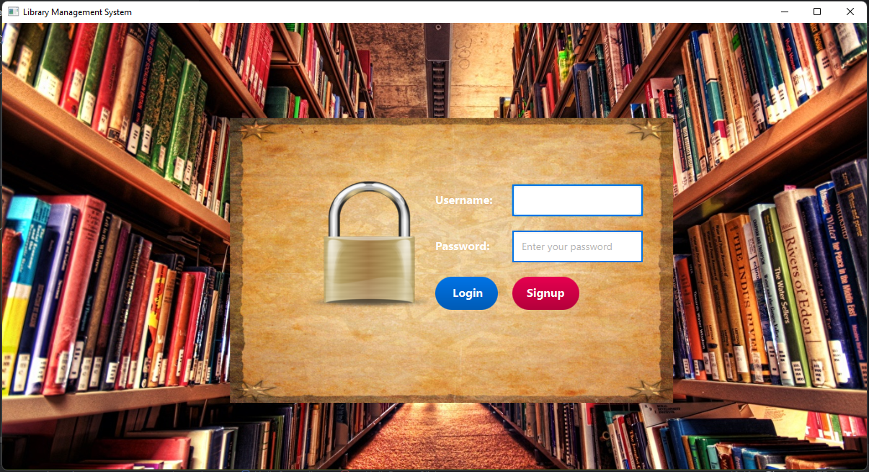

***Signup Page***

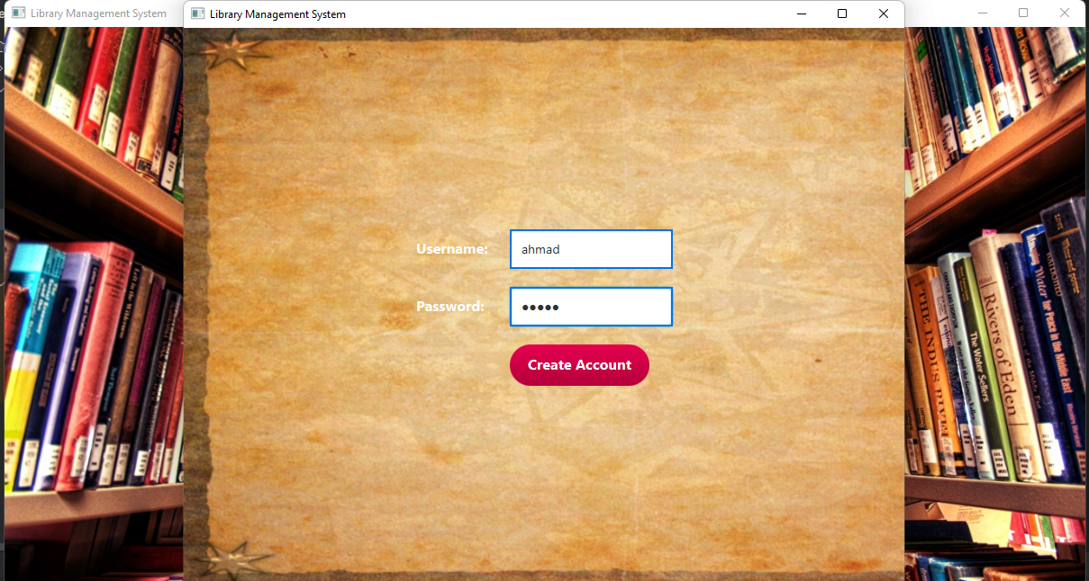

***Error Handling***

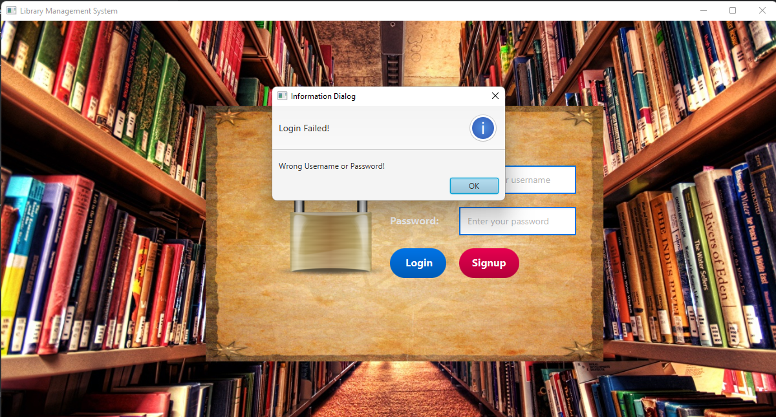

***Dashboard Functionalities***

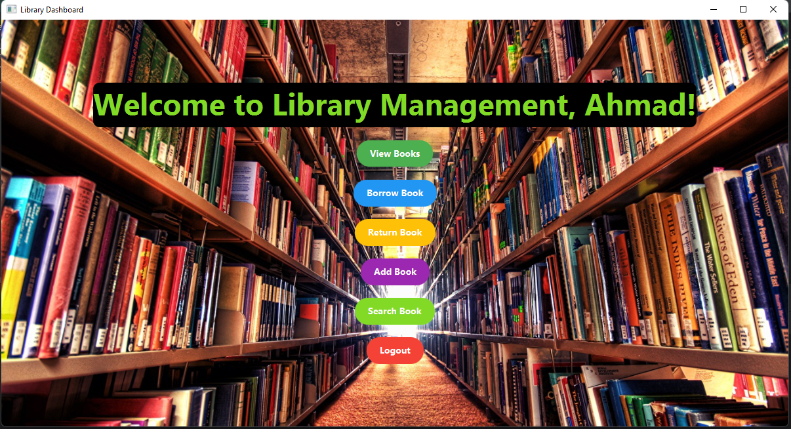

***Adding Books***

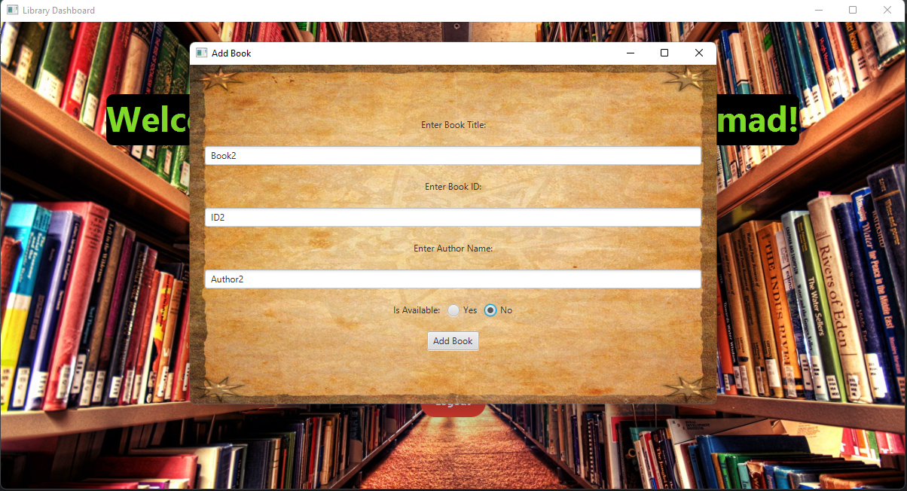

***Displaying Books***

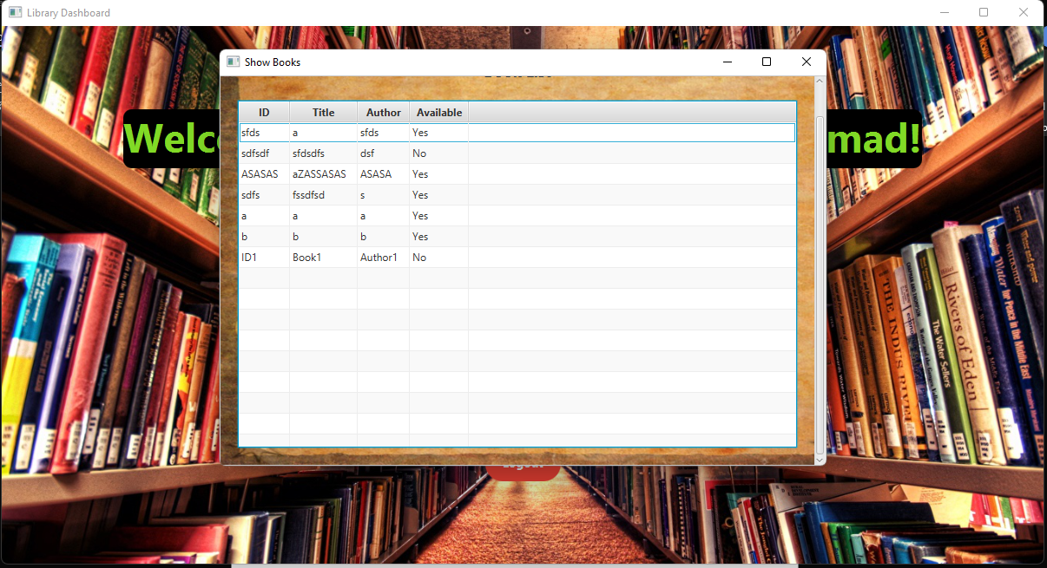

***Borrow and Return Books***

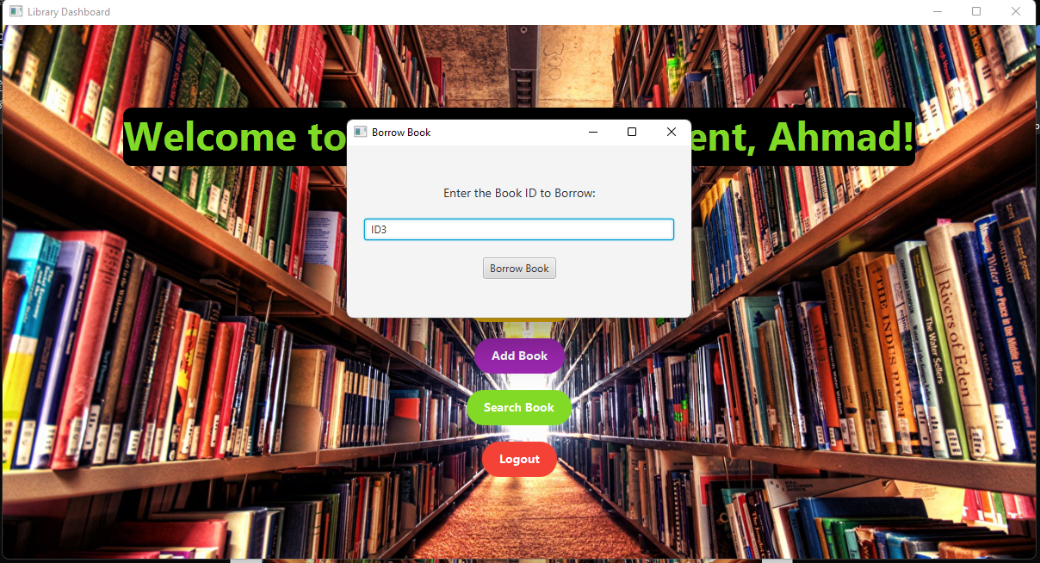

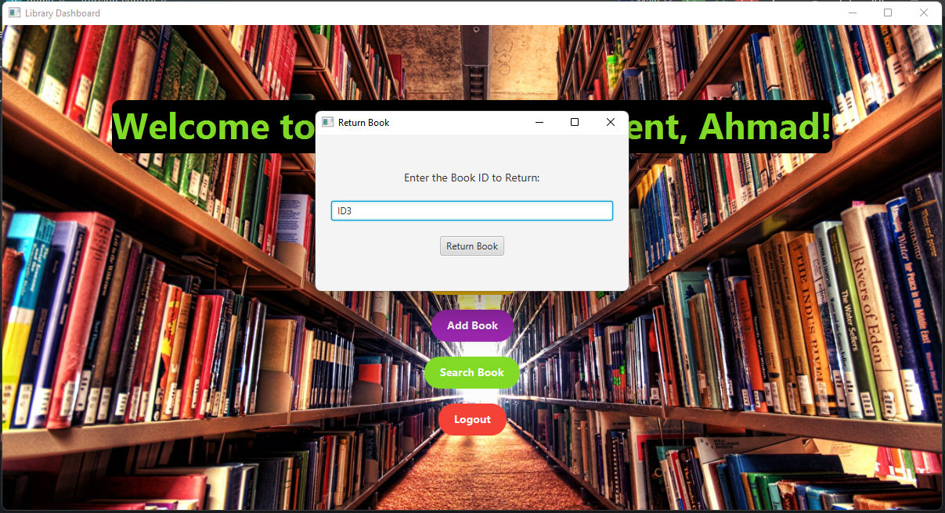

***Search Books***

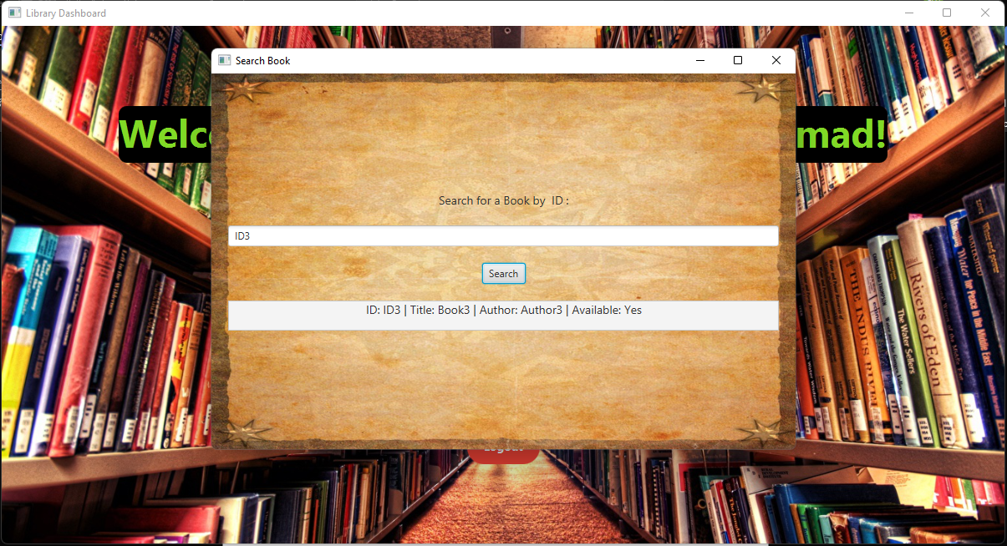

***User can Logout***

